ARTIFICIAL INTELLIGENCE (AI) PREPAREDNESS INDEX BY COUNTRY-DATA ANALYTICS PROJECT
AI PREPAREDNESS BY COUNTRY QUESTIONS
- What are the top 5 countries leading in AI preparedness?
- What are the least 5 countries unprepared for AI?
- Which regions/continents are lagging behind and which ones are leading?
- Do the income levels correlate with AI readiness?
- Which indexes correlates?
DATA SOURCE
- Is the data valid, credible, accurate and is it from a trusted data source
The data is from the World Bank and it is not biased in any way and it has been cleaned and verified to avoid/prevent any errors during the analysis process and also so that the insights are accurate and correct.
DATA CLEANING
- Data was Cleaned in Microsoft excel by checking if there are duplicates in dataset, removing null records, fixing typos and then later on the dataset was double checked in MySQL to confirm that errors are being sorted.
FINDINGS AND INSIGHTS
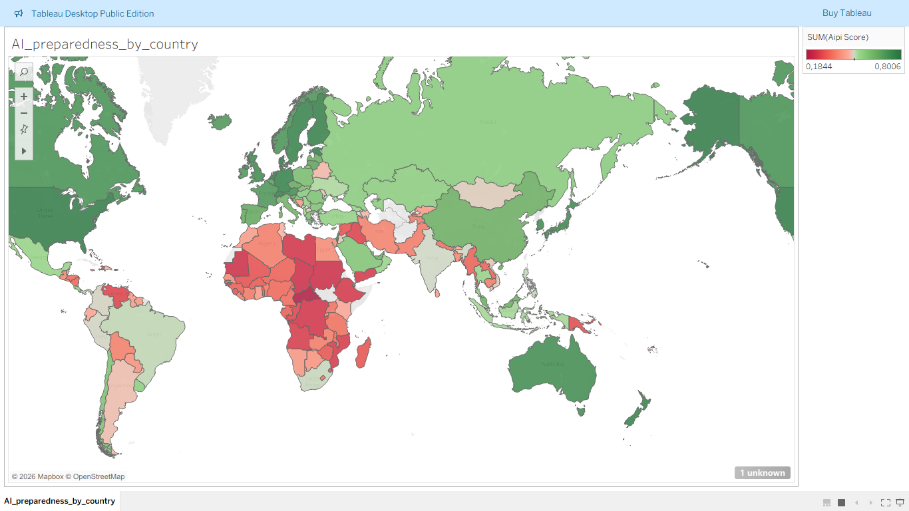
During my analysis I discovered that:
- Countries in North America are leading in the ai preparedness by showing a greater score in ai preparedness. Countries like the USA and Canada showed a great score of AI preparedness
- Many countries in Western and Northern Europe appear greener, indicating higher AI readiness.
- Australia took the third place as the continent that is prepared for AI by the visibility of dark green colour on countries like New Zealand and Australia.
- Asia took the fourth place as the continent that is prepared for AI. This is visible by the light green colour which is visible on countries like China and Japan.
- South America took the fifth place as the continent that is prepared for AI. This is accompanied by lighter green colour on most countries at South America on countries like Brazil and Colombia. Countries like Argentina and Ecuador showed a lower AI score which is visible by light red colour.
- Africa is the least continent ready or prepared for AI as all the countries excluding South Africa showed lower AI score which is visible by light and lighter red colours on most countries on the map. Most countries in central Africa are not prepared for AI.
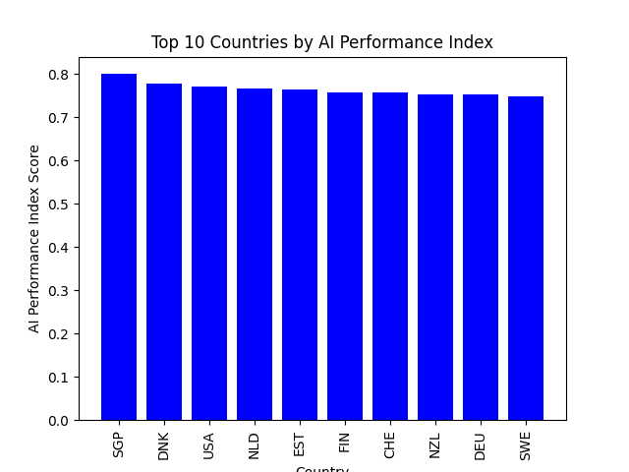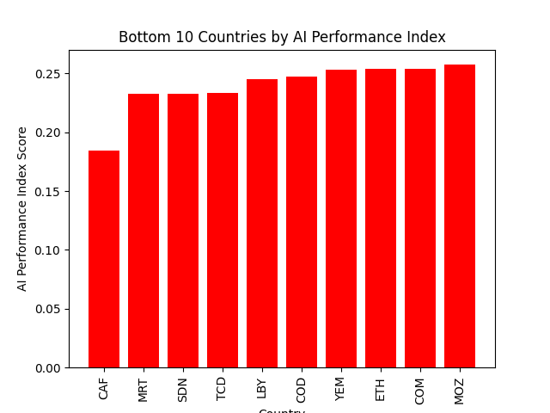
- My analysis indicates that top 10 countries Prepared for AI are mostly from North America and Australia as I have mentioned above and also indicated by the map chart these two continents are leading in the AI preparedness.
- My analysis indicates that bottom 10 countries Prepared for AI are mostly from Africa with few countries from other continents as I have mentioned above and also indicated by the map chart these two continents are leading in the AI preparedness.
